KYAKABADIIMA HC III FACILITY
S/N | Name of Facility | Picture
1 | Kyakabadiima HC III Facility | 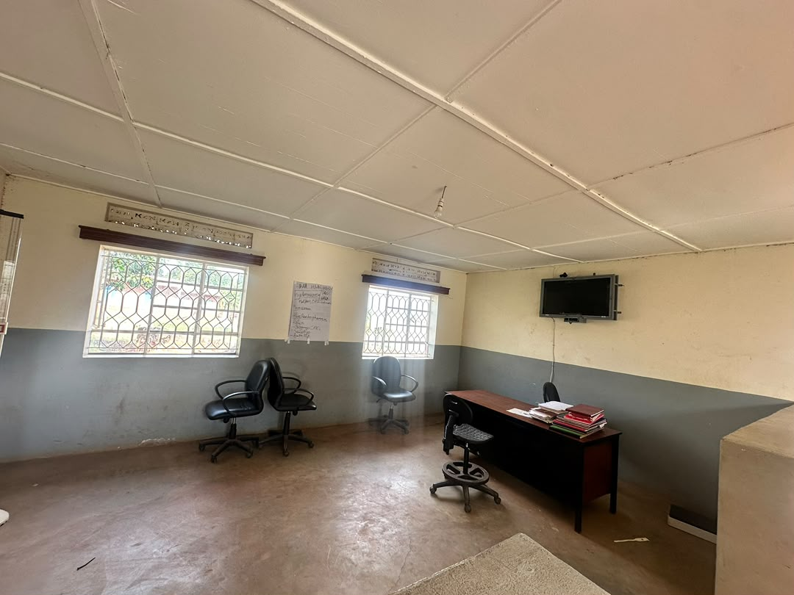
2 | Kyakabadiima HC III Facility  Geteing rusty | 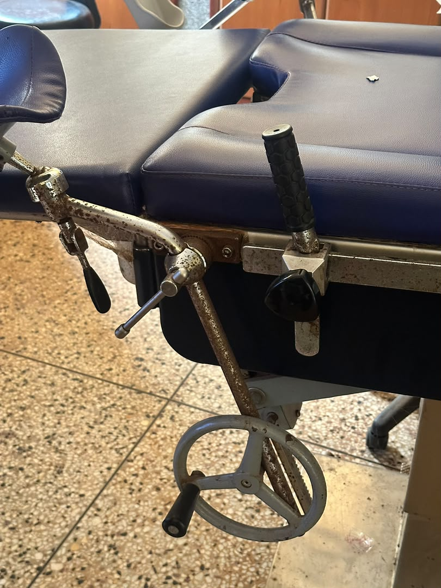
3 | Kyakabadiima HC III Facility | 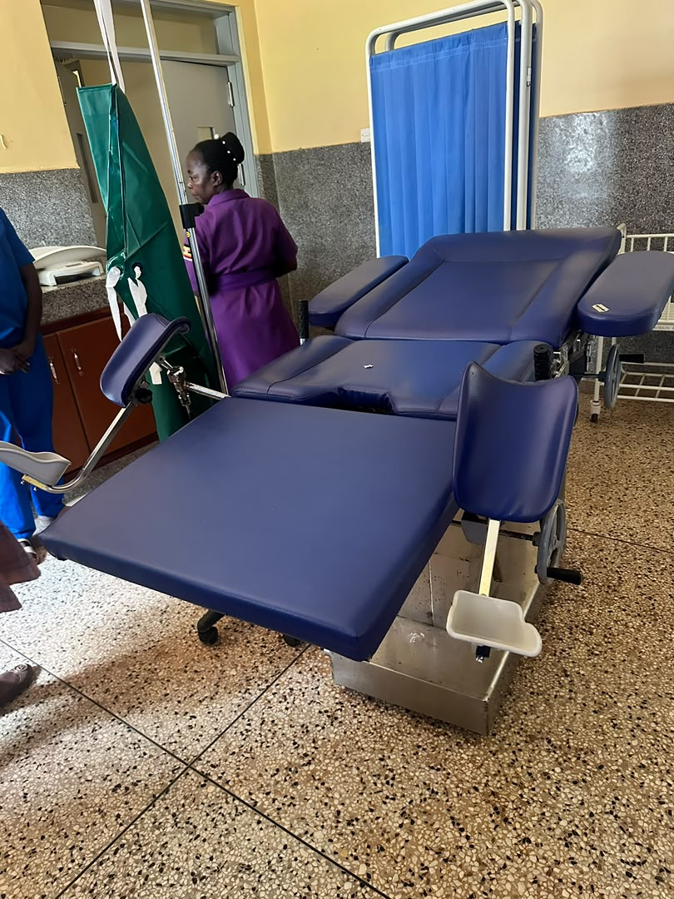
4 | Kyakabadiima HC III Facility | 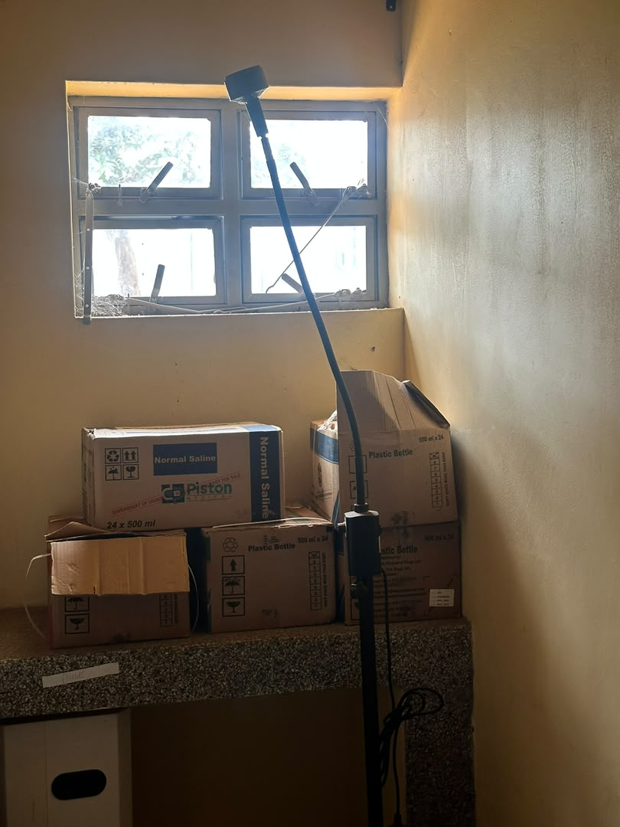
5 | Kyakabadiima HC III Facility | 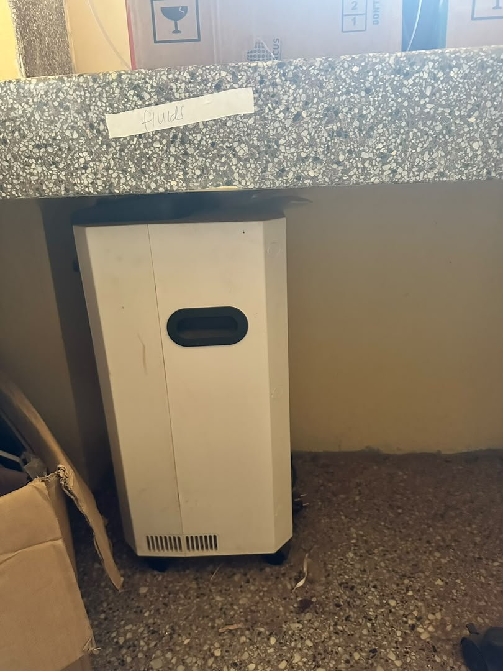
6 | Kyakabadiima HC III Facility | 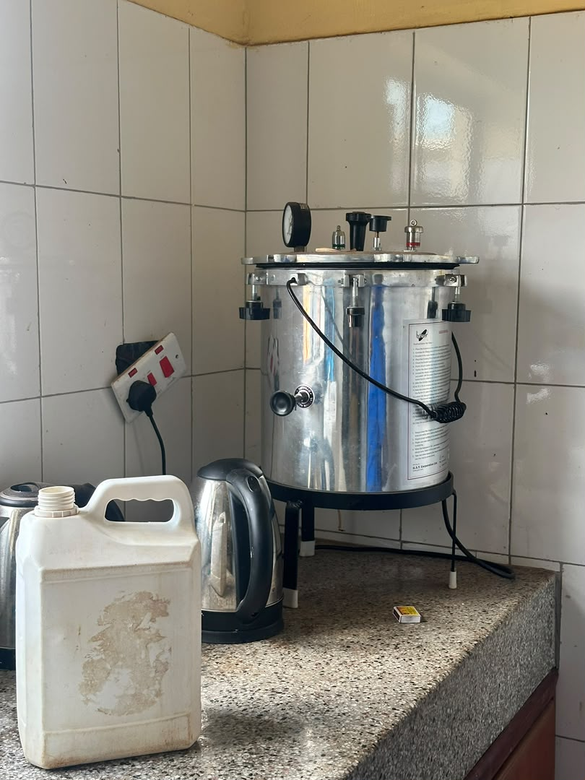
7 | Kyakabadiima HC III Facility  Damaged ceiling | 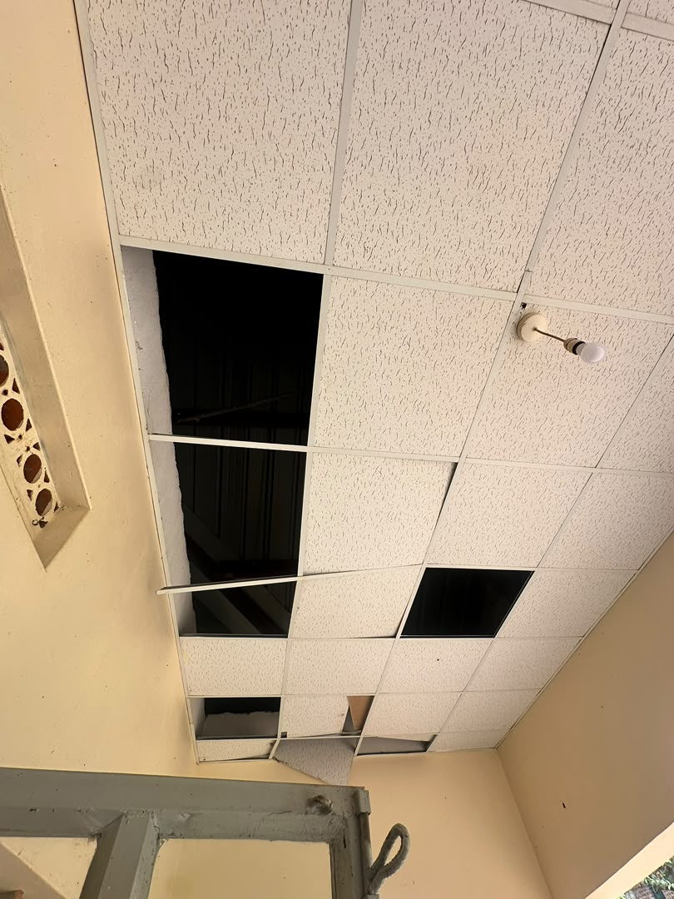
8 | Kyakabadiima HC III Facility | 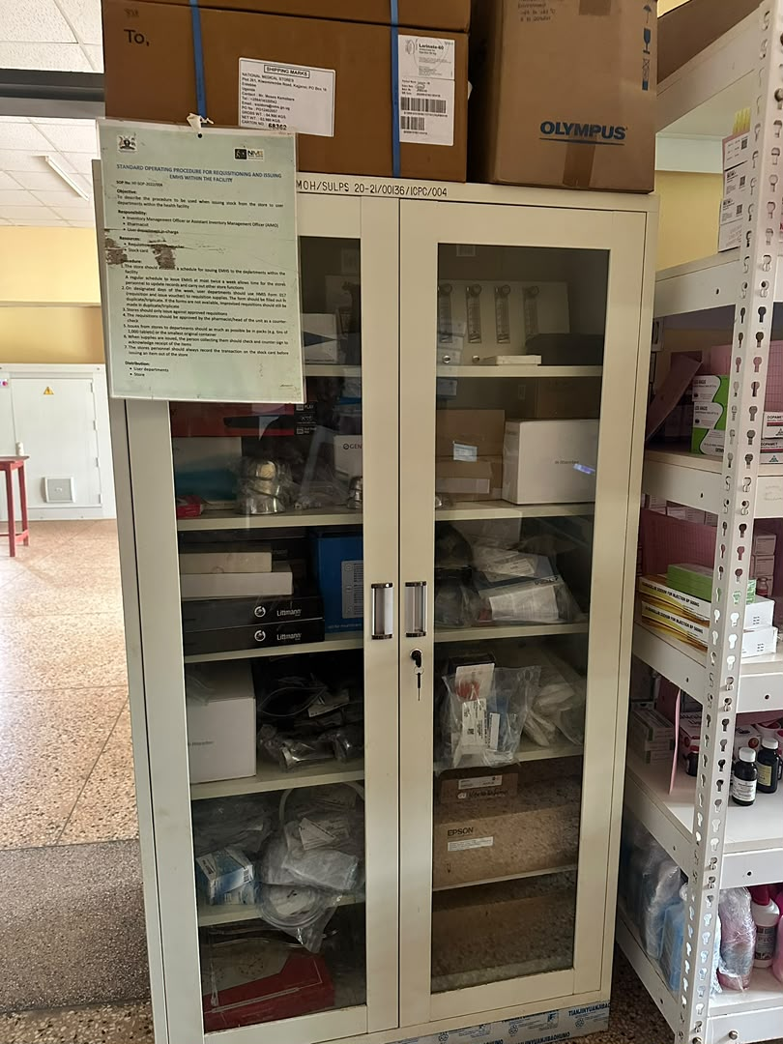
9 | Kyakabadiima HC III Facility | 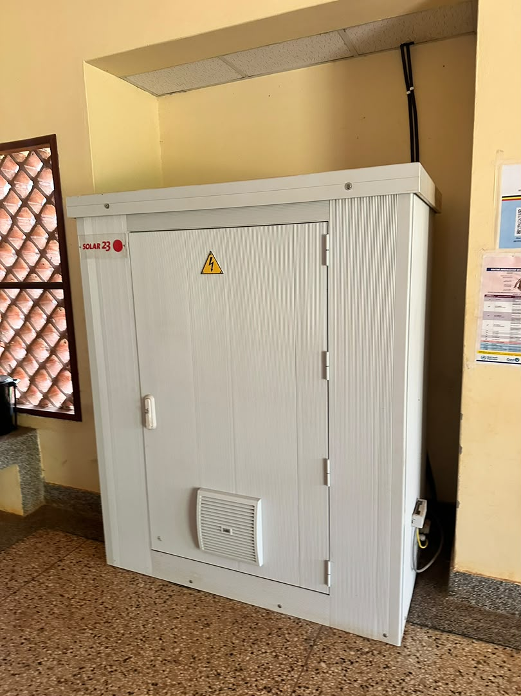
10 | Kyakabadiima HC III Facility | 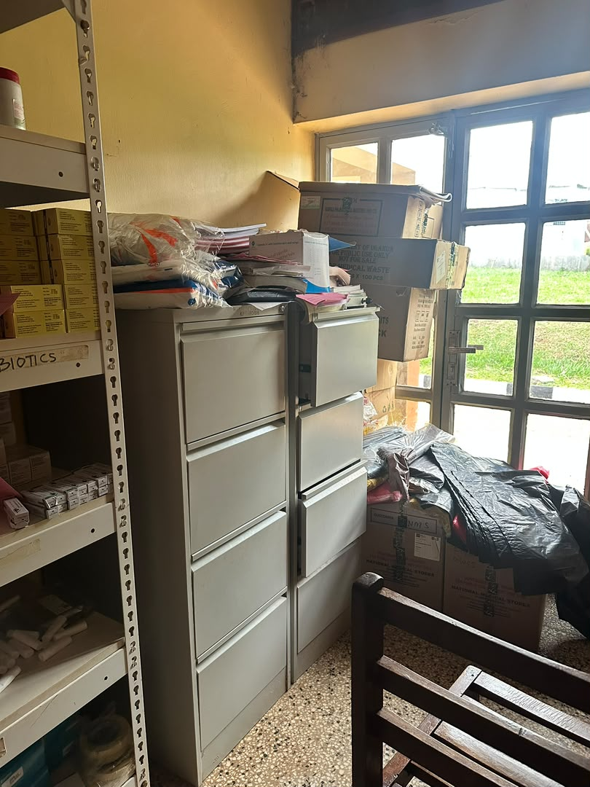
11 | Kyakabadiima HC III Facility | 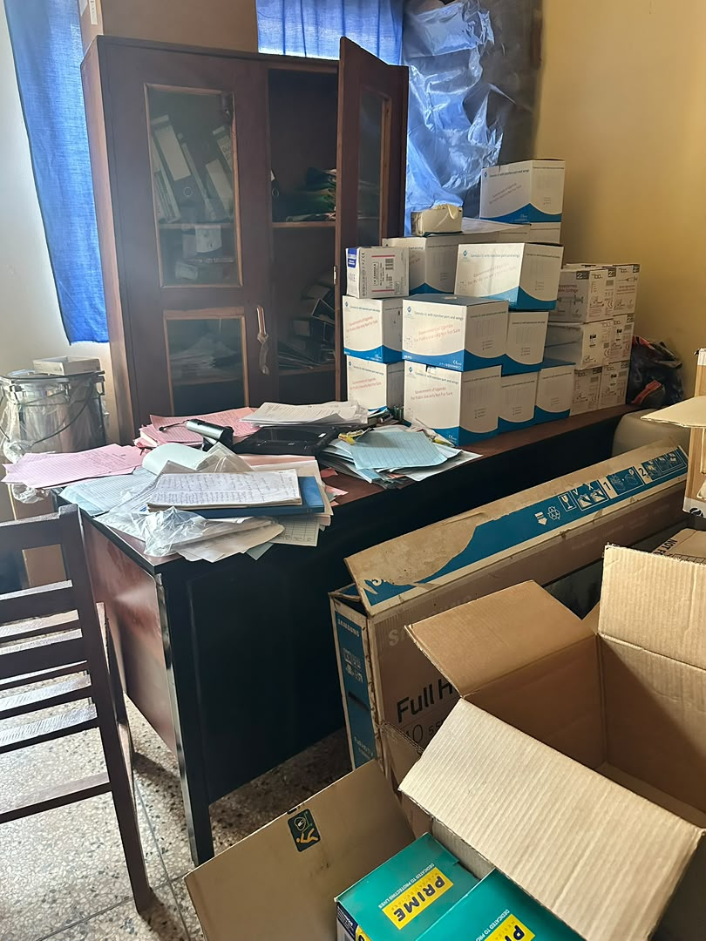
12 | Kyakabadiima HC III Facility | 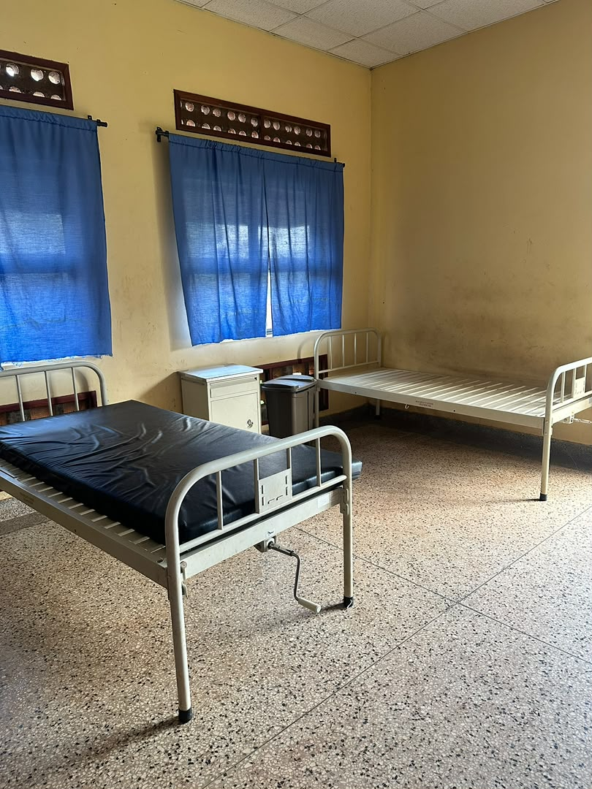
13 | Kyakabadiima HC III Facility | 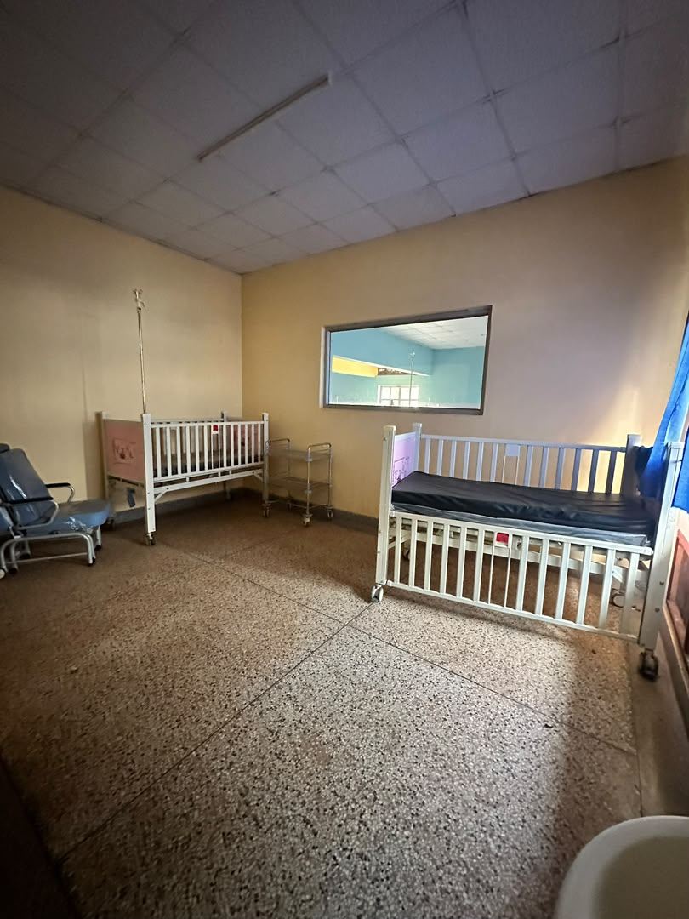
14 | Kyakabadiima HC III Facility | 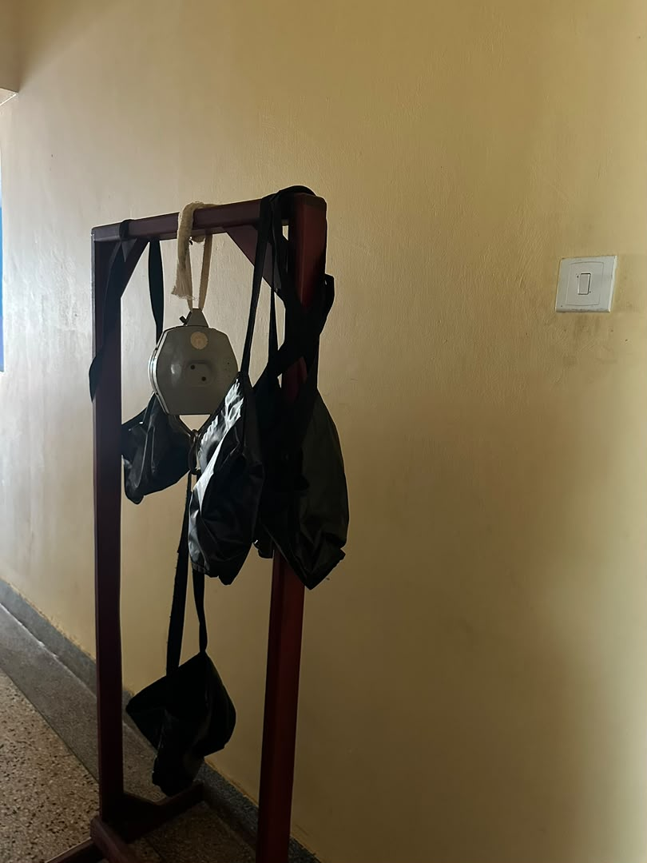
15 | Kyakabadiima HC III Facility | 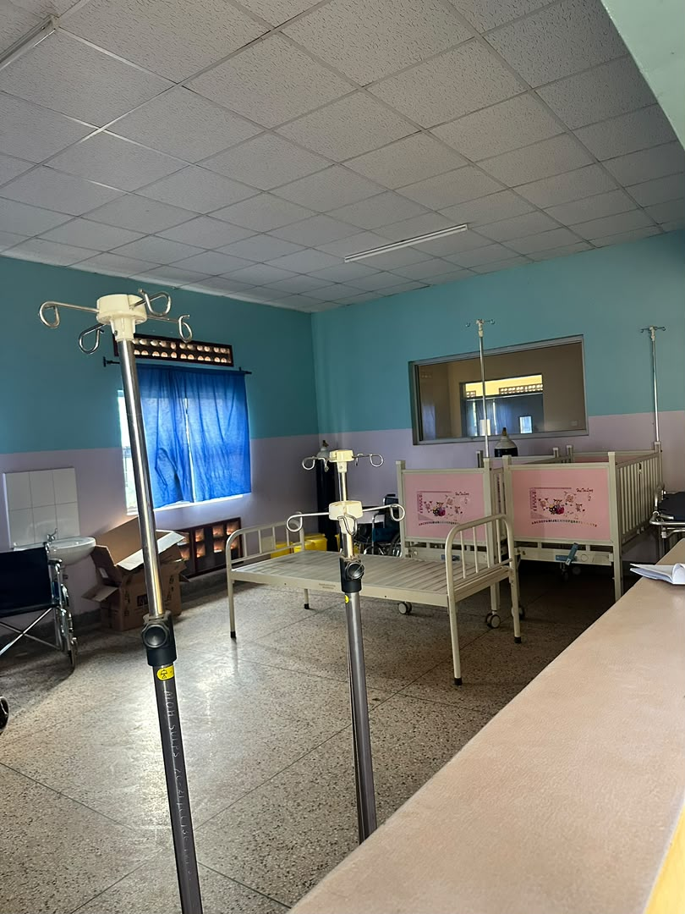
16 | Kyakabadiima HC III Facility | 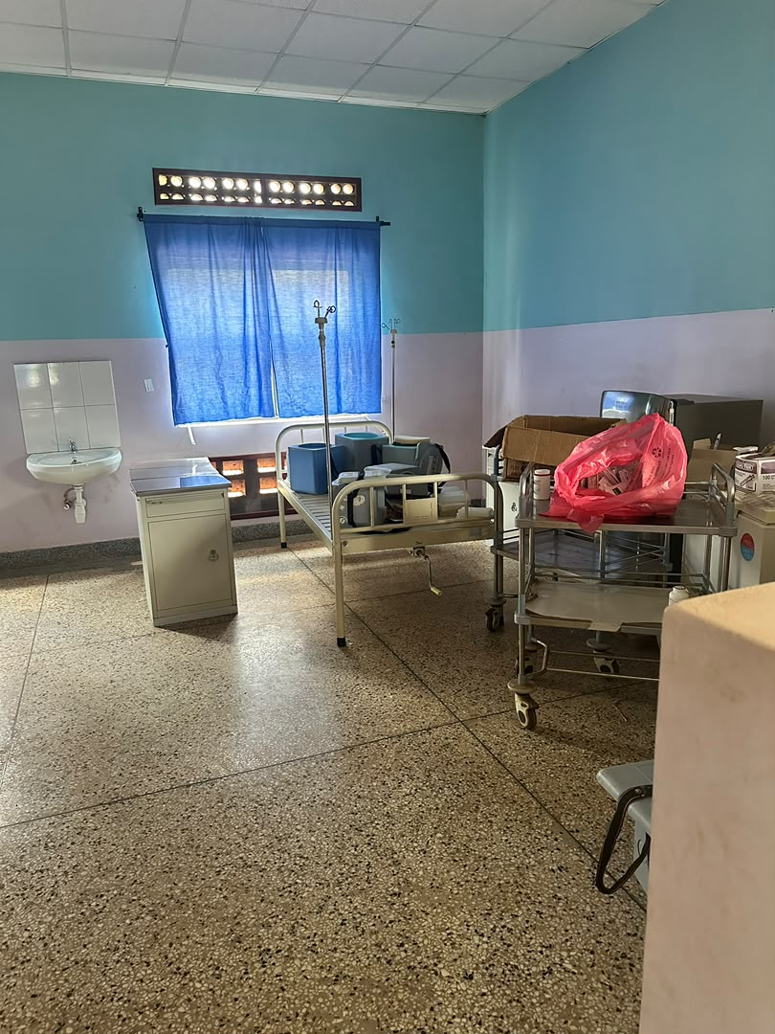
19 | Kyakabadiima HC III Facility | 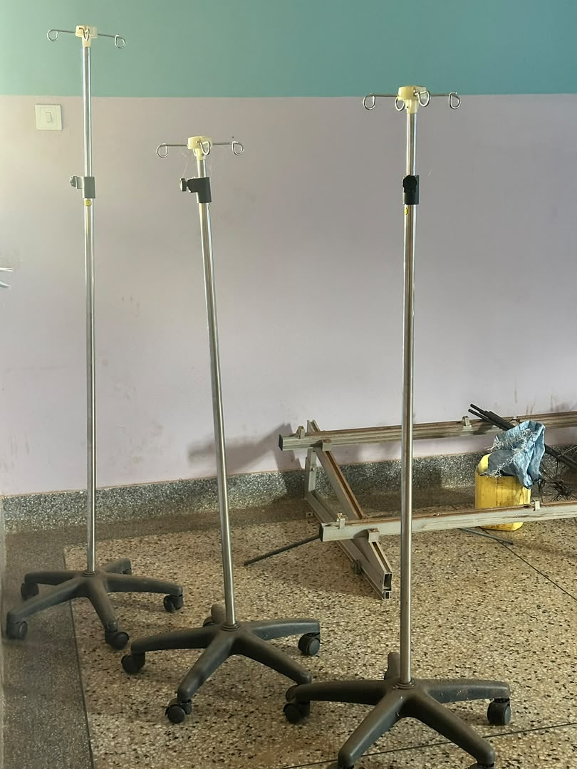
21 | Kyakabadiima HC III Facility | 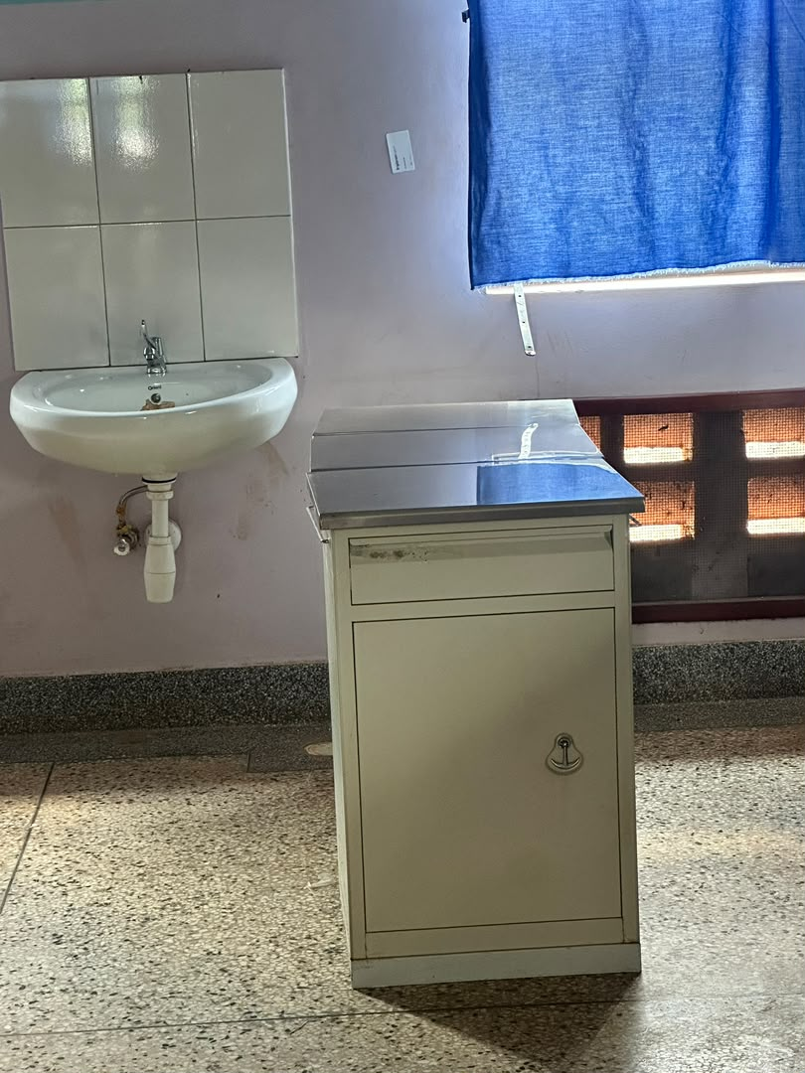
23 | Kyakabadiima HC III Facility | 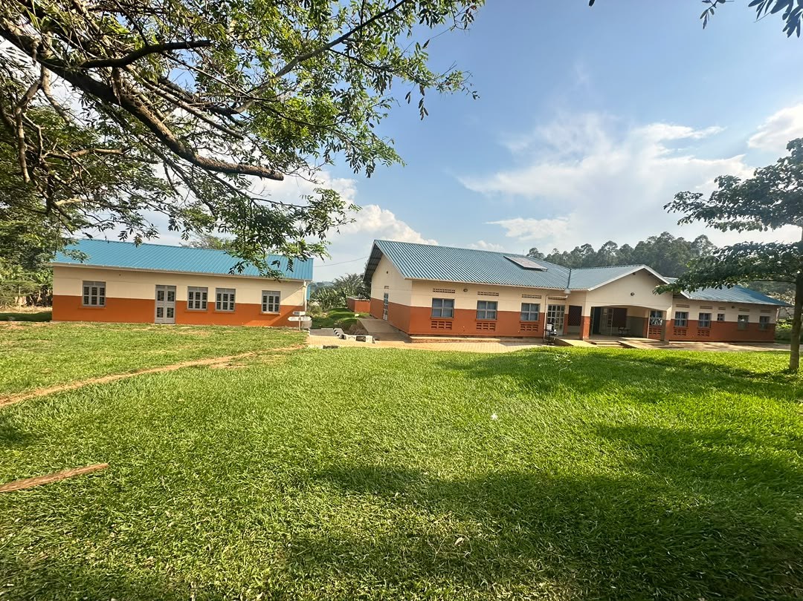
24 | Kyakabadiima HC III Facility | 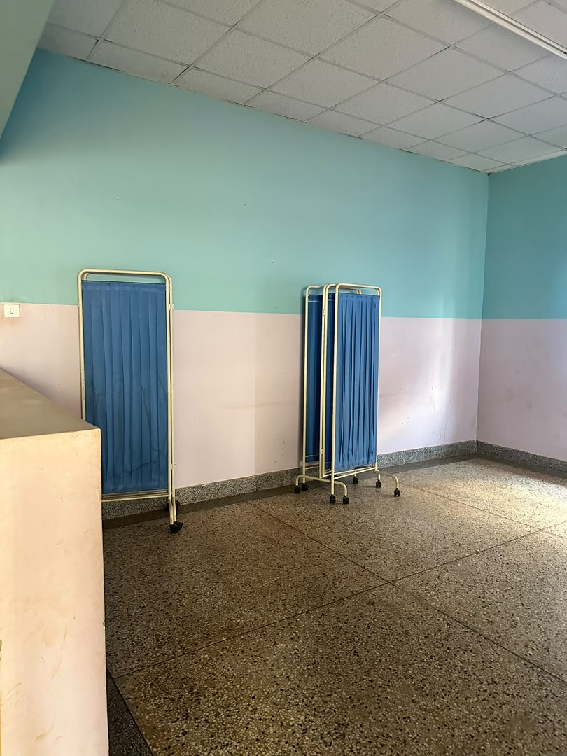
25 | Kyakabadiima HC III Facility | 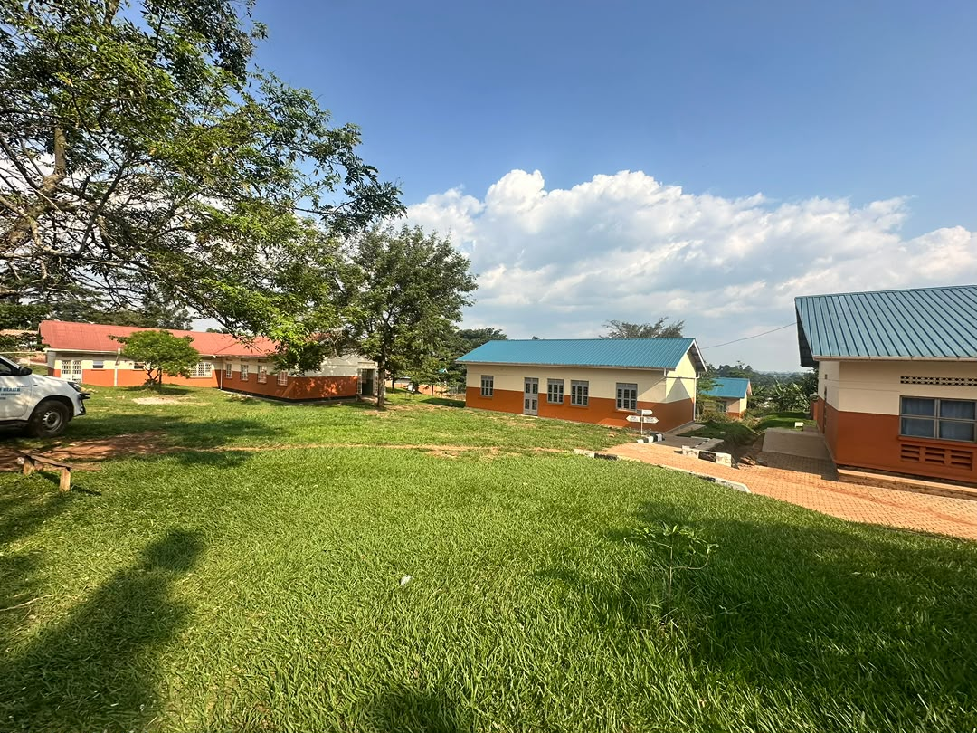
26 | Kyakabadiima HC III Facility | 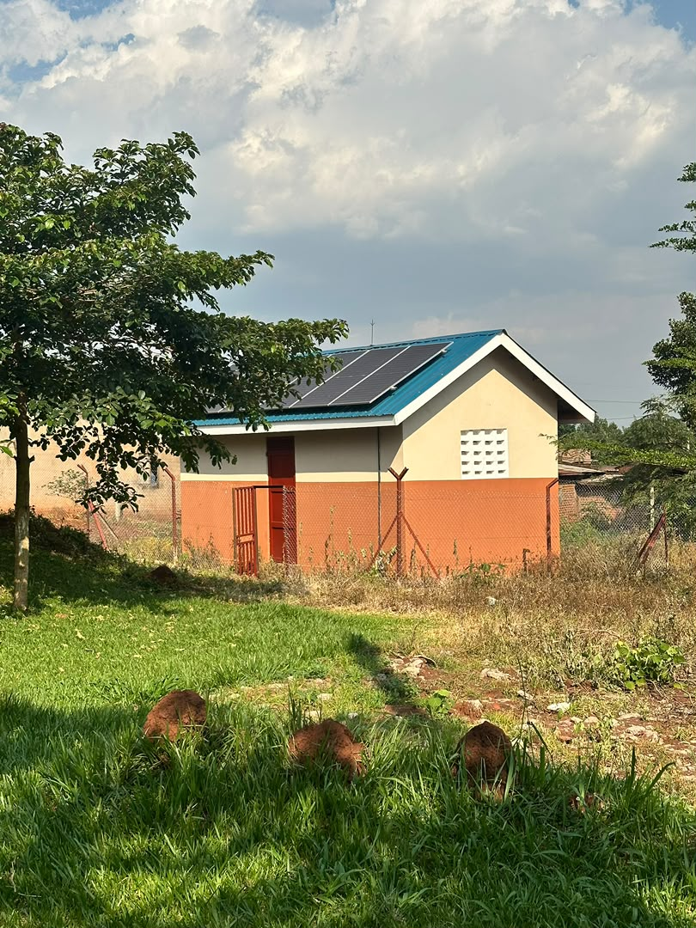
27 | Kyakabadiima HC III Facility | 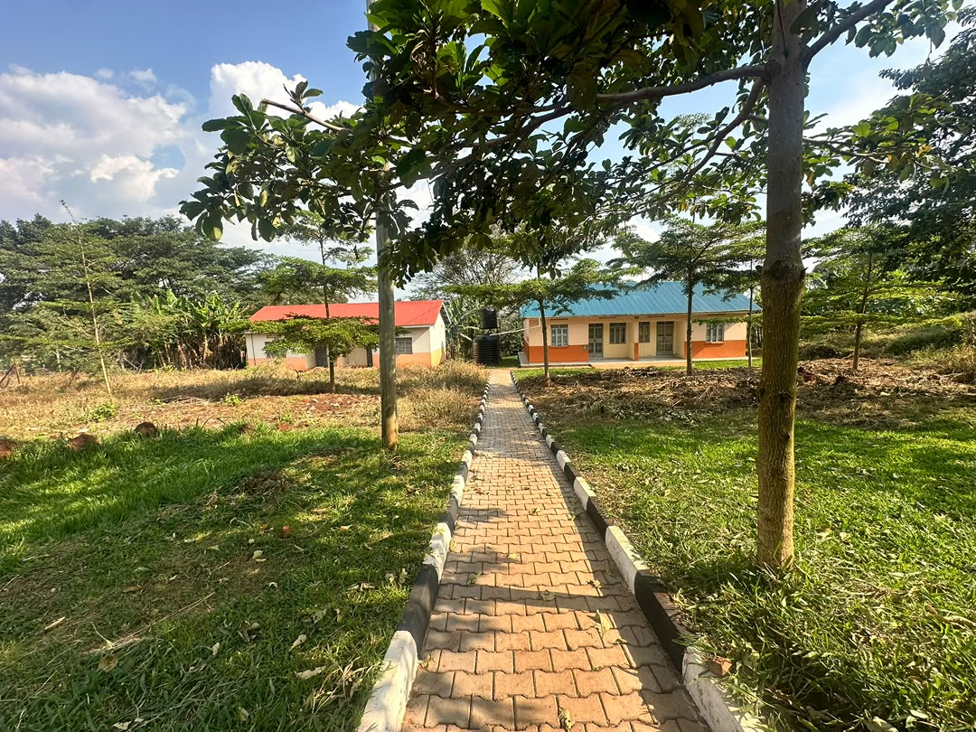
28 | Kyakabadiima HC III Facility | 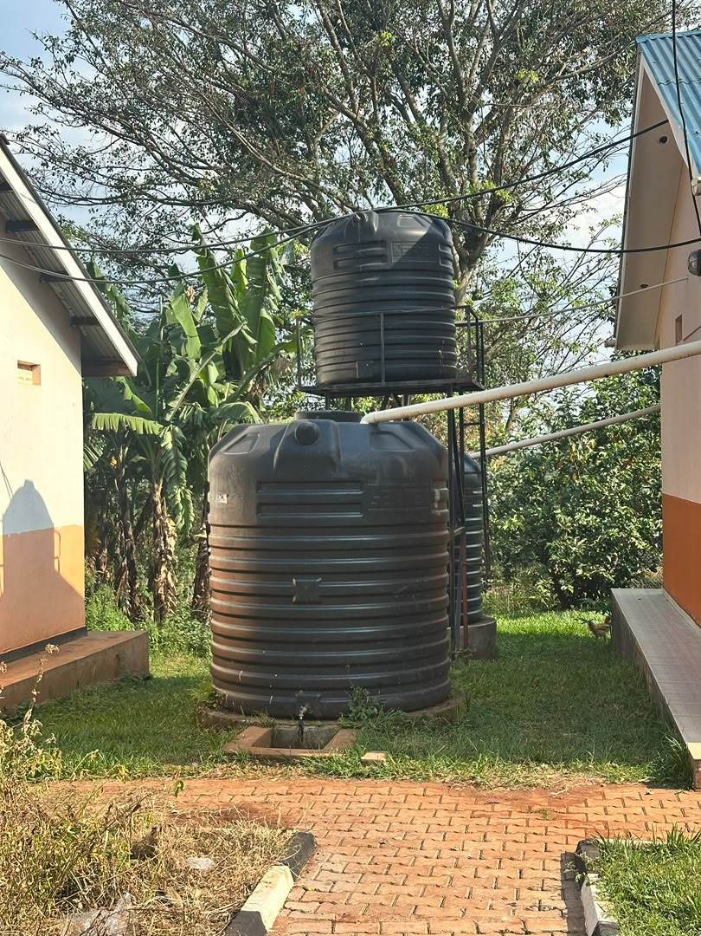
29 | Kyakabadiima HC III Facility | 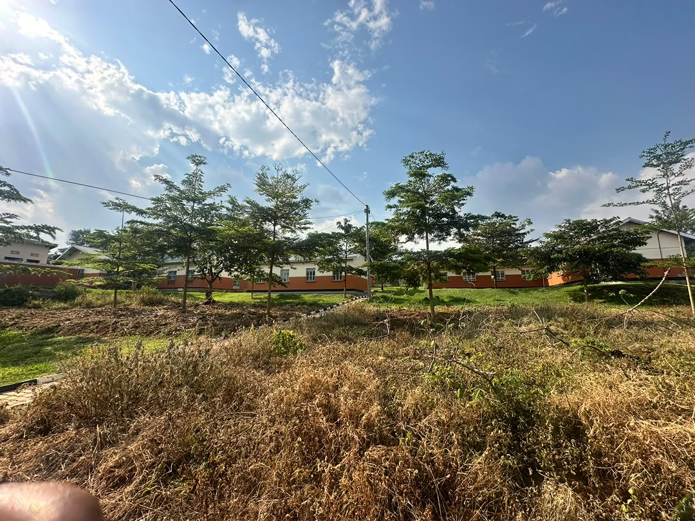
31 | Kyakabadiima HC III Facility | 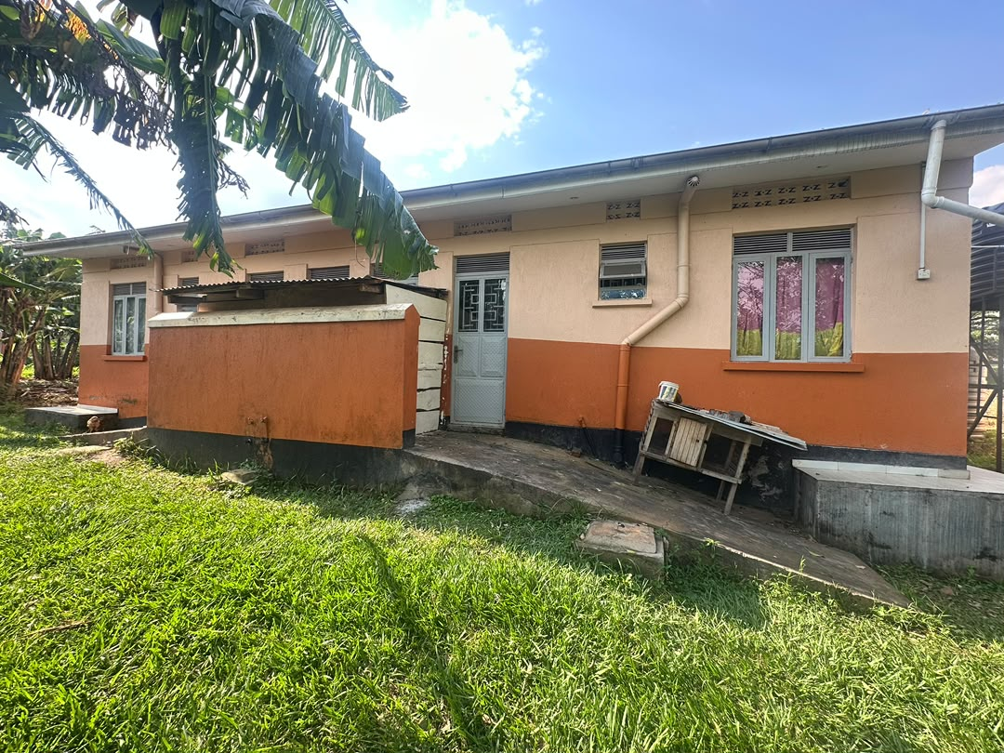
32 | Kyakabadiima HC III Facility | 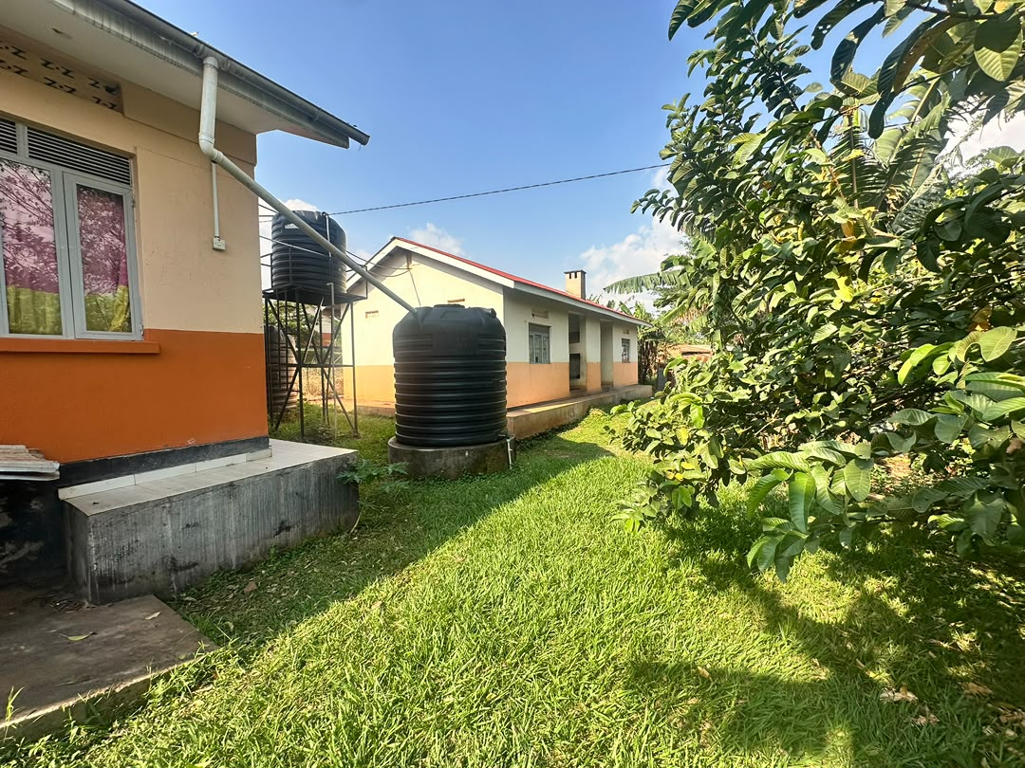
33 | Kyakabadiima HC III Facility | 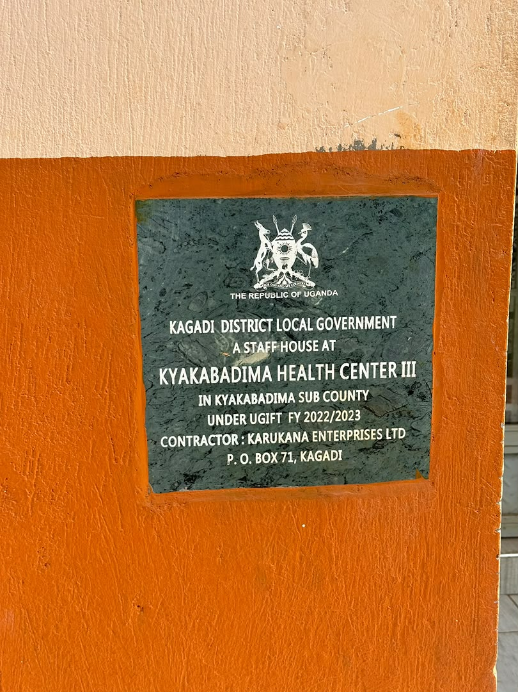
34 | Kyakabadiima HC III Facility | 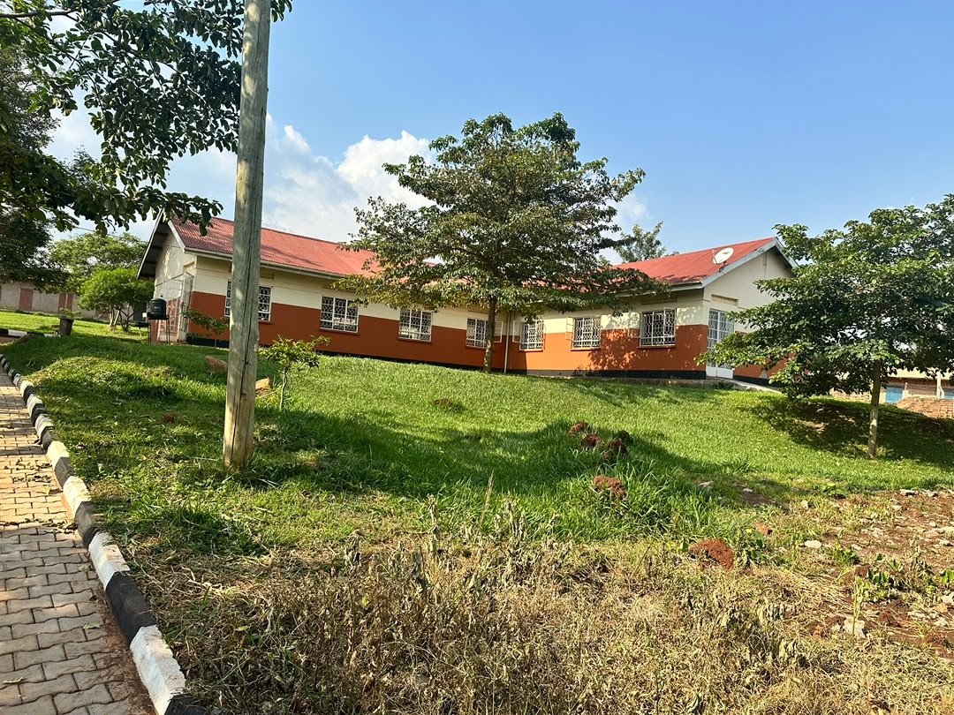
36 | Kyakabadiima HC III Facility | 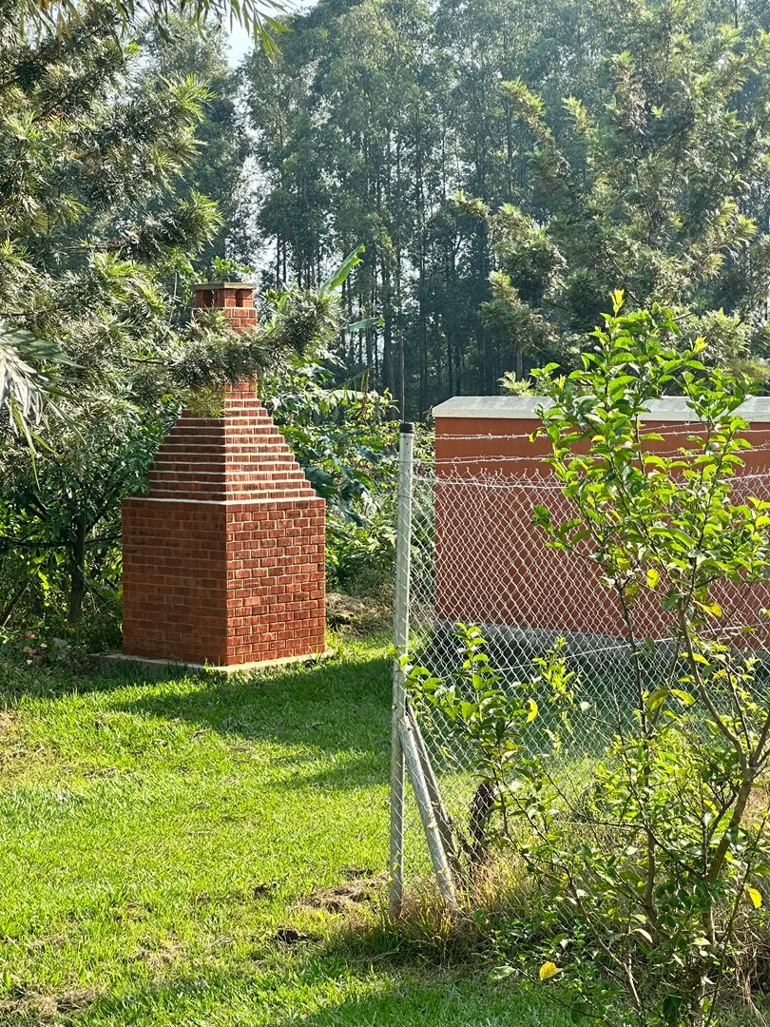
37 | Kyakabadiima HC III Facility | 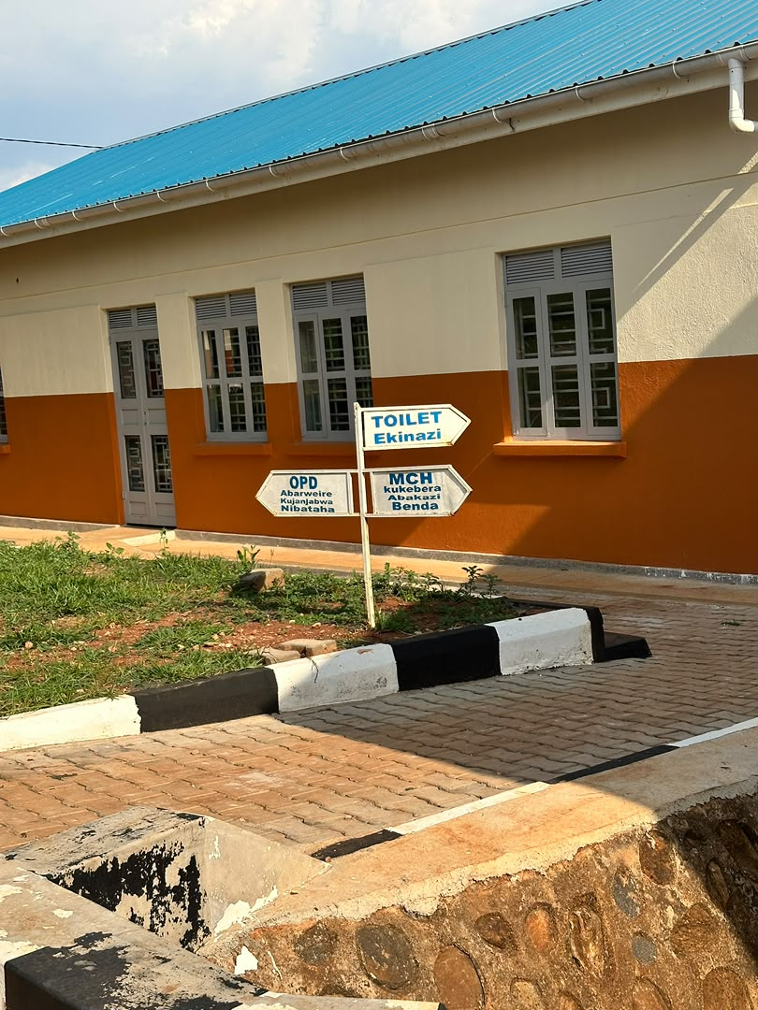
38 | Kyakabadiima HC III Facility | 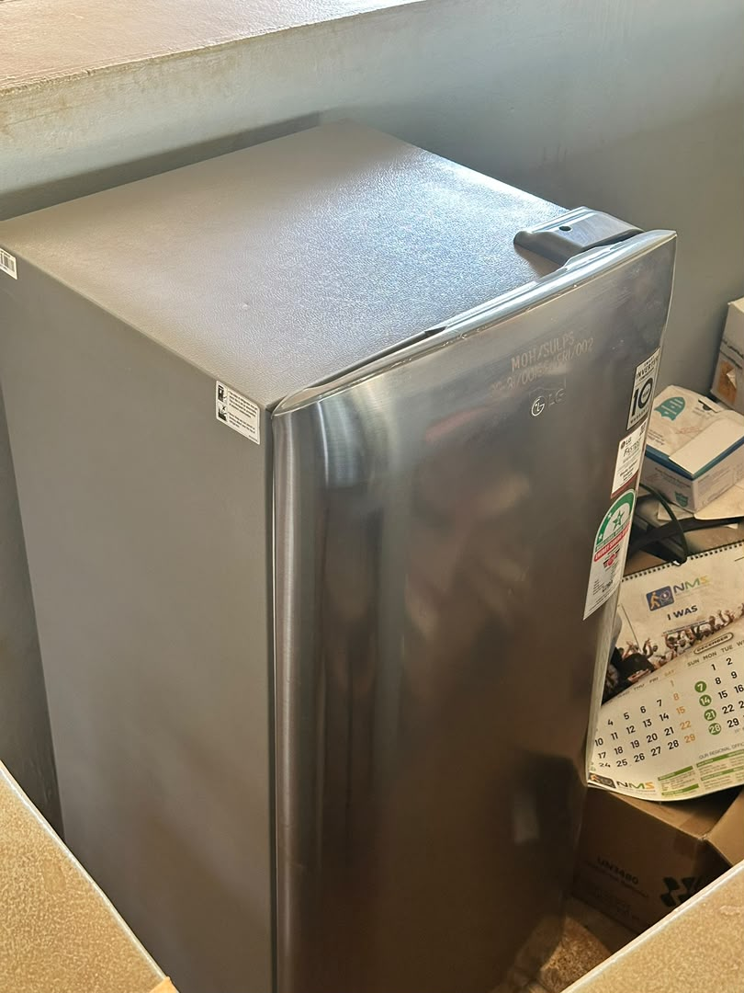
39 | Kyakabadiima HC III Facility | 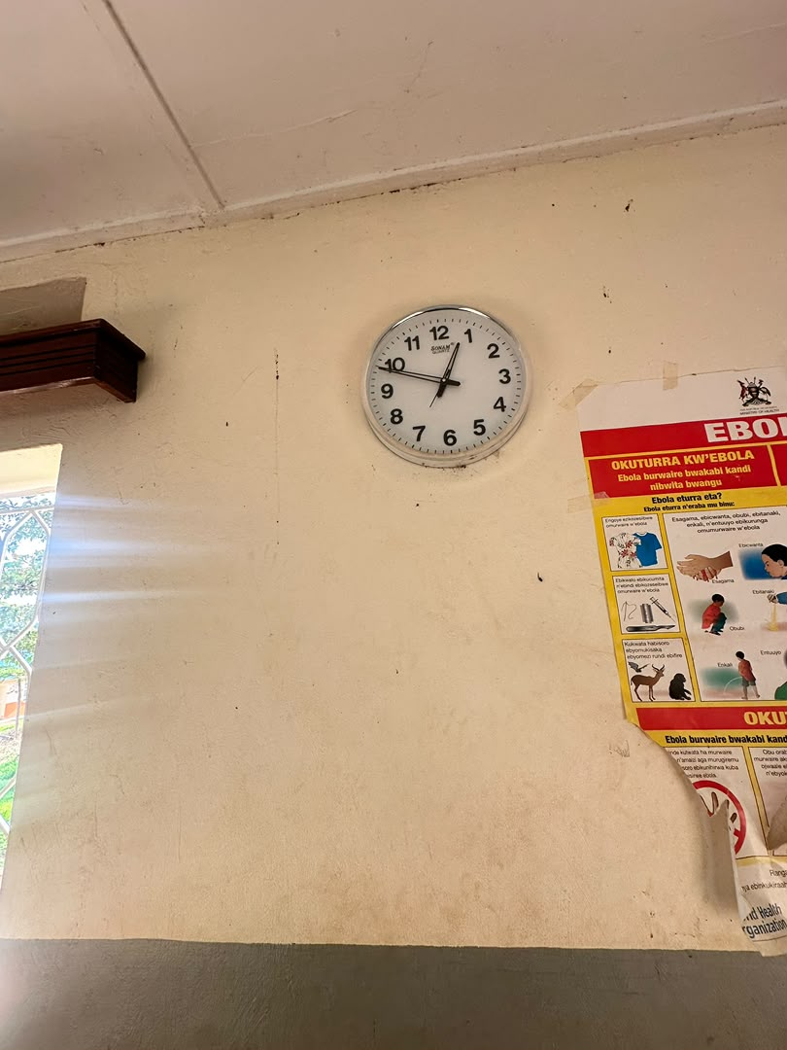
40 | Kyakabadiima HC III Facility | 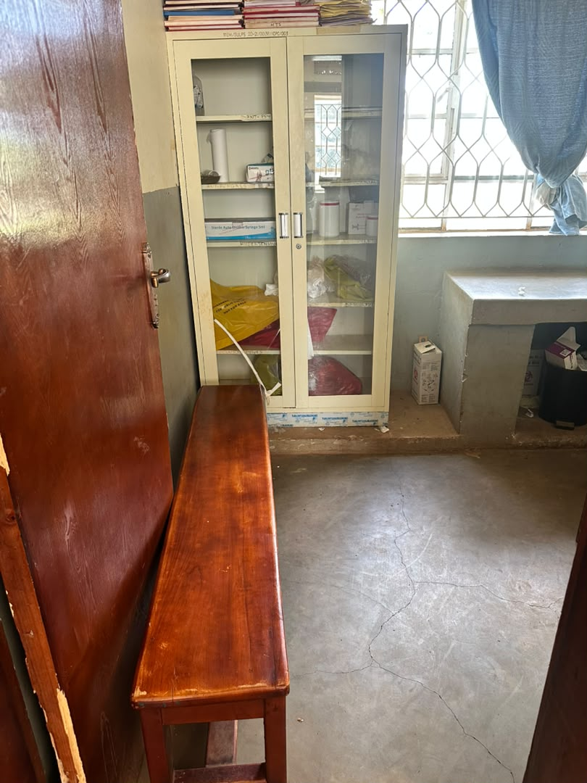
41 | Kyakabadiima HC III Facility | 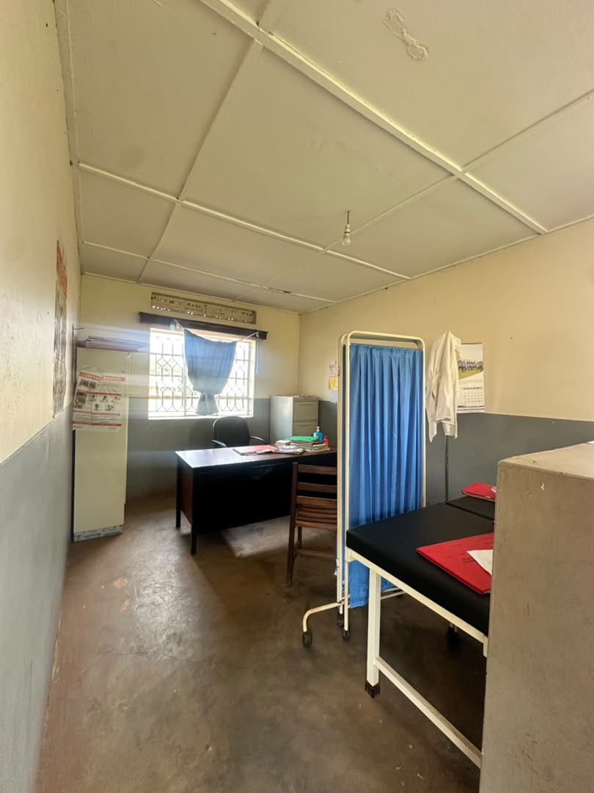
42 | Kyakabadiima HC III Facility | 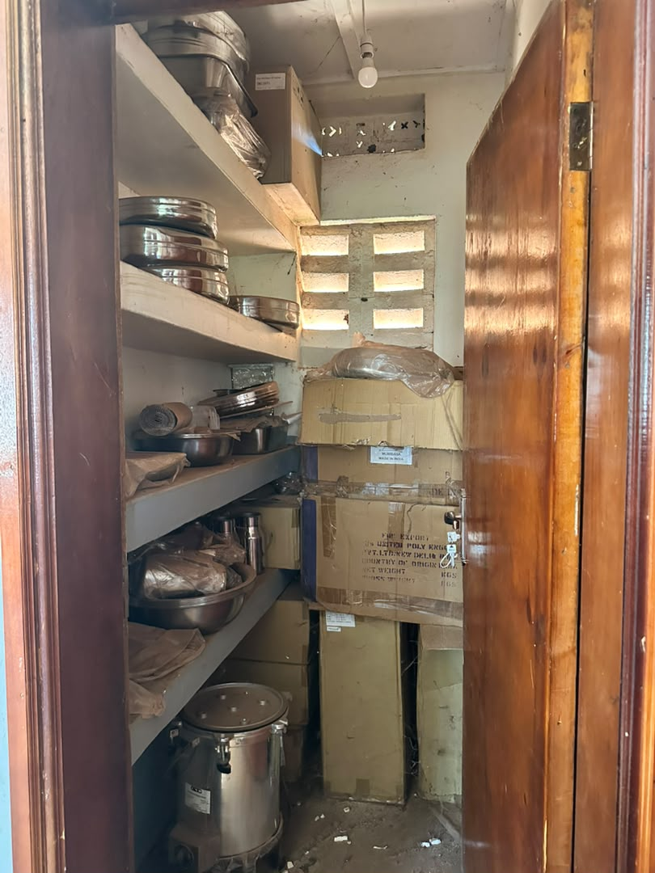
43 | Kyakabadiima HC III Facility | 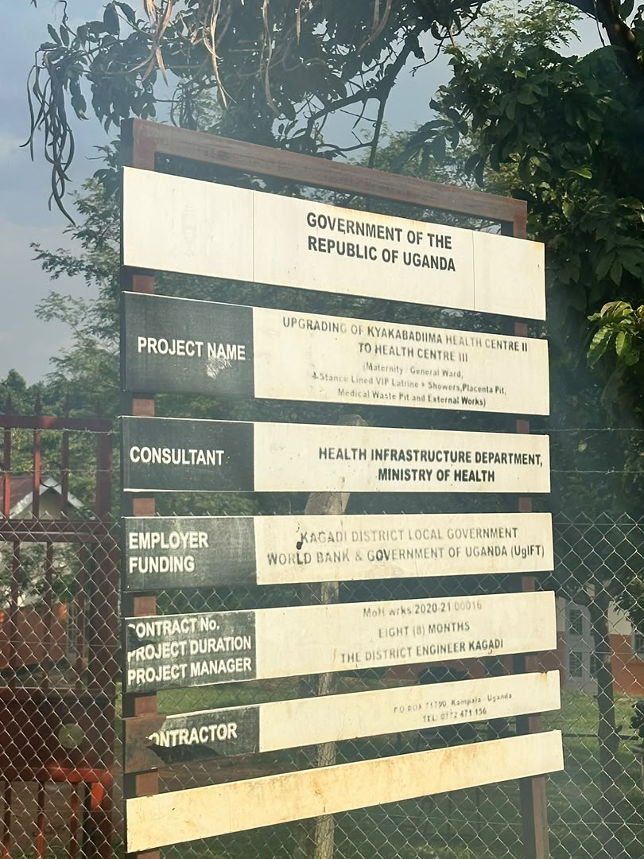
44 | Kyakabadiima HC III Facility | 